Assignment 13

Python programming



LILLEBAELT ACADEMY OF
PROFESSIONAL HIGHER EDUCATION

Author
Martin Grønholdt
mart80c7@edu.eal.dk

Wednesday 3 May 2017

Table of Contents
1. Introduction 1
2. countcode.py 2
3

Introduction
This document describes a Python program to count all lines of python code in a given path.

All hand ins for this course is available on GitHub at:
https://github.com/deadbok/eal_programming

Running
The goal of this program is to count the number of lines in Python files. It does so recursivly starting at the directories given on the command line. The program uses the argparse Python package and includes command line help:

$ python3 countcode.py --help
codecount.py v1.5.0 by Martin B. K. Grønholdt
usage: countcode.py [-h] [--exclude [EXCLUDE [EXCLUDE ...]]]
include [include ...]
Count lines of Python code in given paths.
positional arguments:
include Path to include
optional arguments:
-h, --help show this help message and exit
--exclude [EXCLUDE [EXCLUDE ...]]
Path to exclude
The command line help message.

The above states that the program expect a list of directories to scan, having at least one entry. “--exclude” makes it possible to exclude certain path from the scanning by listing them after the parameter. Excluded directories match the first part of the path, any path that start with a path in the exclude list, are excluded.

$ python3 countcode.py . --exclude ./tools
codecount.py v1.5.0 by Martin B. K. Grønholdt
Include paths:
.
Exclude paths:
./tools
Scanning selected Python files...
c ./countcode.py, b:56,c:41,p:184,t281
e ./tools/py2puml.py, ./tools
Totals:
Files: 2
Duplicate files: 0
Excluded files: 1
Lines: 281
Blank lines: 56
Comment lines: 41
Python code lines: 184
Example of running the code in the project root directory.

The example above tels the program to count all Python file lines in the current directory (.) but exclude files in the tools directory (--exclude ./tools).
- The scanning output starts with a status character:
  - “c” – The file contents are included in the count.
  - “e” - The file is excluded from the count.
  - “d” - The file is excluded from the count, because it is an exact duplicate of another file.
- Next comes the file name and path of the file.
- If the file was included in the count the counts are listed:
  - “b:” - Followed by the number of blank lines.
  - “c:” - Followed by the number of comment lines.
  - “p:” - Followed by the number of Python code lines.
  - “t:” - Followed by the number of total lines.
- If the file is excluded or a duplicate, the offending path is listed instead.

Classes

The uses three internal classes:
- PyFiles – The main class that takes care of recursing the directories and finding the Python source files.
- PyFile
- PyExclude
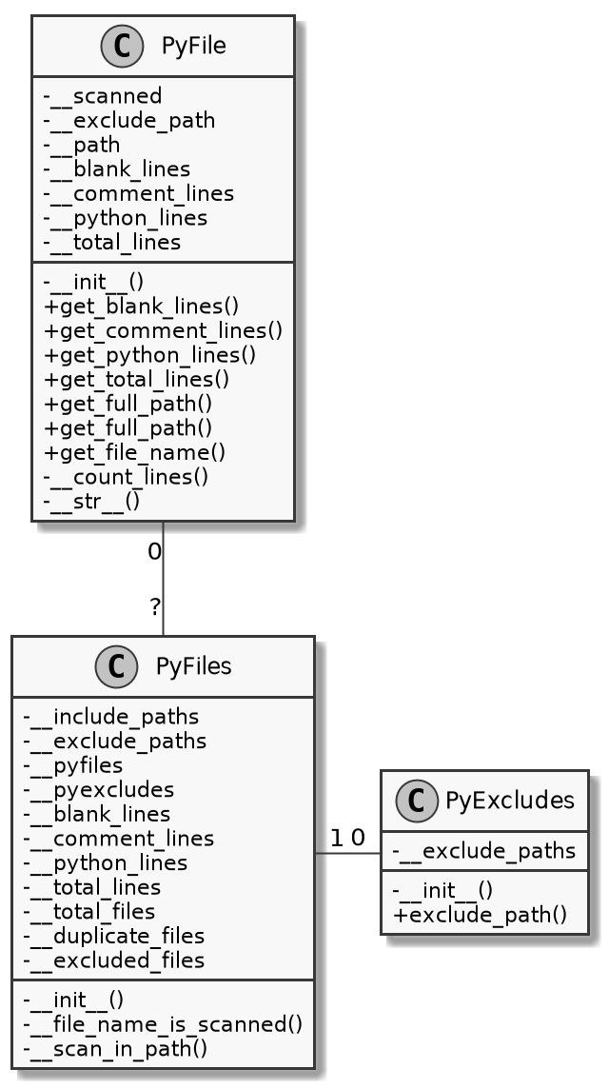
Class diagram

countcode.py
#!/usr/bin/env python3
# -*- coding: utf-8 -*-
# The above lines tell the shell to use python as interpreter when the
# script is called directly, and that this file uses utf-8 encoding,
# because of the country specific letter in my surname.
"""
Name: countcode.py
Author: Martin Bo Kristensen Grønholdt.
Version: 1.5.0 (2017-05-03)

Count the lines of Python code in files in the paths given on the commend line.
"""
import argparse
import os
import fnmatch
import filecmp

__VERSION__ = '1.5.0'

class PyExcludes:
def __init__(self, exclude_paths=[]):
self.__exclude_paths = exclude_paths

def exclude_path(self, path):
# Could have just used return(ex), but my teacher would rather like
# only one return path.
ret = None
for ex in self.__exclude_paths:
if path.startswith(ex):
ret = ex
break

return ret

class PyFile:
def __init__(self, path=None, exclude_path=None, duplicate_path=None):
# File has not been scanned.
self.__scanned = False
# Save exclude path.
self.__exclude_path = exclude_path

if exclude_path is not None:
# File is excluded, set status and do not scan.
self.__status = 'e'
self.__scanned = True
elif duplicate_path is not None:
# File is a duplicate, set status and do not scan.
self.__status = 'd'
self.__scanned = True
self.__exclude_path = duplicate_path
else:
# File is to be counted, set status and scan.
self.__status = 'c'

self.__path = path
self.__blank_lines = 0
self.__comment_lines = 0
self.__python_lines = 0
self.__total_lines = 0

self.__count_lines()

def get_blank_lines(self):
return self.__blank_lines

def get_comment_lines(self):
return self.__comment_lines

def get_python_lines(self):
return self.__python_lines

def get_total_lines(self):
return self.__total_lines

def get_full_path(self):
return self.__path

def get_full_path(self):
return self.__path

def get_file_name(self):
return os.path.basename(self.__path)

def __count_lines(self):
"""
Scan a path for Python files.

:param path: Path to file to process.
:return: A tuple with the blank lines, comment lines, python lines,
total lines.
"""
if (self.__exclude_path is None) and (not self.__scanned):
# Open the file.
with open(self.__path, 'r', encoding="latin-1") as python_file:
# Reset counters.
self.__blank_lines = 0
self.__comment_lines = 0
self.__python_lines = 0
self.__total_lines = 0

# Run through all lines in the file.
for line in python_file.readlines():
# Add to total lines.
self.__total_lines += 1

# Remove trailing spaces and tabs.
line = line.lstrip(' \t')

# Check for a blank line.
if line.startswith('\n'):
self.__blank_lines += 1
# Check for a comment.
elif line.startswith('#'):
self.__comment_lines += 1
# Count as a line of Python code.
else:
self.__python_lines += 1

self.__scanned = True

def __str__(self):
ret = '{0}\t{1}'.format(self.__status,
self.__path)

if (self.__exclude_path is None):
ret += ', b:{0},c:{1},p:{2},t{3}'.format(self.__blank_lines,
self.__comment_lines,
self.__python_lines,
self.__total_lines)

if (self.__exclude_path is not None):
ret += ', {0}'.format(self.__exclude_path)

return ret

class PyFiles:
def __init__(self, include_paths=['.'], exclude_paths=None):
# Save paths
self.__include_paths = include_paths
self.__exclude_paths = exclude_paths

# Array of PyFiles
self.__pyfiles = []
# Excluded paths handler.
self.__pyexcludes = PyExcludes(exclude_paths)

# Print paths
print('Include paths:')
for path in self.__include_paths:
print('\t{}'.format(path))
if self.__exclude_paths is not None:
print('Exclude paths:')
for path in self.__exclude_paths:
print('\t{}'.format(path))

self.__blank_lines = 0
self.__comment_lines = 0
self.__python_lines = 0
self.__total_lines = 0

self.__total_files = 0
self.__duplicate_files = 0
self.__excluded_files = 0

# Scan all files.
print('\nScanning selected Python files...')
for path in self.__include_paths:
self.__scan_in_path(path)

for pyfile in self.__pyfiles:
self.__blank_lines += pyfile.get_blank_lines()
self.__comment_lines += pyfile.get_comment_lines()
self.__python_lines += pyfile.get_python_lines()
self.__total_lines += pyfile.get_total_lines()

# Print result.
print('\nTotals:')
print('\tFiles: {}'.format(self.__total_files))
print('\tDuplicate files: {}'.format(self.__duplicate_files))
print('\tExcluded files: {}'.format(self.__excluded_files))
print('\tLines: {}'.format(self.__total_lines))
print('\tBlank lines: {}'.format(self.__blank_lines))
print('\tComment lines: {}'.format(self.__comment_lines))
print('\tPython code lines: {}'.format(self.__python_lines))

def __file_name_is_scanned(self, filename):
# Could have just used return(pyfile.get_full_path()), but my teacher would rather like
# only one return path.
ret = None
for pyfile in self.__pyfiles:
if pyfile.get_file_name() == filename:
ret = pyfile.get_full_path()
break

return ret

def __scan_in_path(self, path):
"""
Scan a path for Python files.

:param include_paths: List of path to include when scanning.
:param exclude_paths: List of paths to exclude when scanning.
:return: A tuple with the number of total files, duplicate files,
excluded files, blank lines, comment lines, python lines,
total lines.
"""
# Use os.walk to recursivly decent the directory.
for root, dirnames, filenames in os.walk(path):
# Find all .py files in th path.
for filename in fnmatch.filter(filenames, '*.py'):
# Assemble the current path.
current_path = os.path.join(root, filename)

self.__total_files += 1

exclude_path = self.__pyexcludes.exclude_path(current_path)

# Check for duplicates if not excluded.
duplicate_path = None
if exclude_path is None:
duplicate_path = self.__file_name_is_scanned(filename)
if duplicate_path is not None:
if not filecmp.cmp(duplicate_path, current_path):
duplicate_path = None
else:
self.__duplicate_files += 1
else:
self.__excluded_files += 1

pyfile = PyFile(current_path,
exclude_path,
duplicate_path)
self.__pyfiles.append(pyfile)
print(pyfile)

def parse_commandline():
"""
Parse command line arguments.

:return: A tuple with a list of files path to include, and a list of paths
to exclude.
"""
# Set up the arguments to have included paths as positional arguments,
# and excluded path using --exclude.
parser = argparse.ArgumentParser(description='Count lines of Python ' +
'code in given paths.')
# Include parameter, at least one entry is needed.
parser.add_argument('include', default=['.'], nargs='+',
help='Path to include')
# Eclude paramater.
parser.add_argument('--exclude', dest='exclude', nargs='*',
help='Path to exclude')

# Parse command line
args = parser.parse_args()

# Return the paths.
return ((args.include, args.exclude))

def main():
"""
Program main entry point.
"""
# Print welcome message
print(
'codecount.py v{} by Martin B. K. Grønholdt\n'.format(__VERSION__))
# Parse the command line.
paths = parse_commandline()

PyFiles(paths[0], paths[1])

# Run this when invoked directly
if __name__ == '__main__':
main()

Result
$ python3 countcode.py ../.. /home/oblivion/sync-src /home/oblivion/src --exclude /home/oblivion/sync-src/.metadata \ /home/oblivion/sync-src/python/ssg/build /home/oblivion/sync-src/enigmabox-openwrt /home/oblivion/sync-src/lcdproc \ /home/oblivion/sync-src/cg/commgroup.dk /home/oblivion/sync-src/Static\ Site\ Generator/
codecount.py v1.5.0 by Martin B. K. Grønholdt
Include paths:
../..
/home/oblivion/sync-src
/home/oblivion/src
Exclude paths:
/home/oblivion/sync-src/.metadata
/home/oblivion/sync-src/python/ssg/build
/home/oblivion/sync-src/enigmabox-openwrt
/home/oblivion/sync-src/lcdproc
/home/oblivion/sync-src/cg/commgroup.dk
/home/oblivion/sync-src/Static Site Generator/
Scanning selected Python files...
---
c ../../programming/ass13/countcode.py, b:56,c:41,p:184,t281
c ../../programming/ass13/tools/py2puml.py, b:24,c:61,p:89,t174
---
c ../../programming/SQLite 10/config.py, b:1,c:3,p:7,t11
c ../../programming/SQLite 10/run.py, b:1,c:3,p:7,t11
d ../../programming/SQLite 10/__init__.py, ../../intro-project/roy/motor/ws/__init__.py
c ../../programming/SQLite 10/app/__init__.py, b:3,c:4,p:26,t33
c ../../programming/SQLite 10/app/models/customerdb.py, b:13,c:17,p:82,t112
c ../../programming/SQLite 10/app/models/__init__.py, b:0,c:0,p:1,t1
c ../../programming/SQLite 10/app/views/add.py, b:6,c:4,p:28,t38
c ../../programming/SQLite 10/app/views/customertable.py, b:4,c:3,p:18,t25
c ../../programming/SQLite 10/app/views/__init__.py, b:0,c:0,p:2,t2
c ../../programming/SQLite 10/tools/py2puml.py, b:24,c:61,p:89,t174
---
e /home/oblivion/sync-src/lcdproc/ez_setup.py, /home/oblivion/sync-src/lcdproc
e /home/oblivion/sync-src/lcdproc/setup.py, /home/oblivion/sync-src/lcdproc
e /home/oblivion/sync-src/lcdproc/examples.py, /home/oblivion/sync-src/lcdproc
e /home/oblivion/sync-src/lcdproc/lcdproc/__init__.py, /home/oblivion/sync-src/lcdproc
e /home/oblivion/sync-src/lcdproc/lcdproc/menu.py, /home/oblivion/sync-src/lcdproc
e /home/oblivion/sync-src/lcdproc/lcdproc/screen.py, /home/oblivion/sync-src/lcdproc
e /home/oblivion/sync-src/lcdproc/lcdproc/widgets.py, /home/oblivion/sync-src/lcdproc
e /home/oblivion/sync-src/lcdproc/lcdproc/server.py, /home/oblivion/sync-src/lcdproc
---
Totals:
Files: 485
Duplicate files: 56
Excluded files: 110
Lines: 29310
Blank lines: 4651
Comment lines: 3592
Python code lines: 21067
Program output, outut has been truncated at the “---” markers.

Output
c ../../programming/ass13/countcode.py, b:56,c:41,p:184,t281

d ../../programming/SQLite 10/__init__.py, ../../intro-project/roy/motor/ws/__init__.py

e /home/oblivion/sync-src/lcdproc/ez_setup.py, /home/oblivion/sync-src/lcdproc

